# Handsmen Threads – Salesforce CRM & Automation Implementation

Empowering Business Through Intelligent Automation

Presented by: Moolinti Pradeep Kumar Reddy

College: Gates Institute of Technology

## Project Overview

Project Aim:  
To digitize and streamline Handsmen Threads' lead, order, and inventory management using Salesforce CRM.  
  
Key Focus Areas:  
- Centralized Data  
- Automated Workflows  
- Real-Time Dashboards  
- Email Notifications

## Project Objectives

- Implement Salesforce CRM for sales and customer management  
- Automate lead-to-order process  
- Enable order approvals and status tracking  
- Build dashboards and reports for business insights

## Modules Implemented

1. Lead & Opportunity Management  
2. Order & Inventory Automation  
3. Email Notification Flows  
4. Approval Processes  
5. Reports & Dashboards

## Custom Objects & Data Model

Custom Objects:  
- Handsmen_Thread (Thread details)  
- Thread_Order (Customer orders)  
- Inventory  
  
Relationships:  
- Thread_Order ↔ Handsmen_Thread (Lookup)  
- Thread_Order ↔ Contact / Account

## Flow Automation Examples

- Approval Flow: Triggers email → wait for approval → update status  
- Inventory Flow: Confirms order → adjusts inventory  
- Email Flow: Sends confirmation to customer

## Reports & Dashboards

Implemented Dashboards:  
- Weekly Sales Summary  
- Lead Source Pie Chart  
- Inventory Health Report

## Key Results & Benefits

- 80% reduction in manual data entry  
- Fast, trackable order approvals  
- Enhanced visibility for managers  
- Streamlined communication with customers

## Conclusion

Salesforce enabled Handsmen Threads to transform traditional processes into a seamless, automated workflow—boosting both efficiency and customer satisfaction.

# Appendix: Project Screenshots

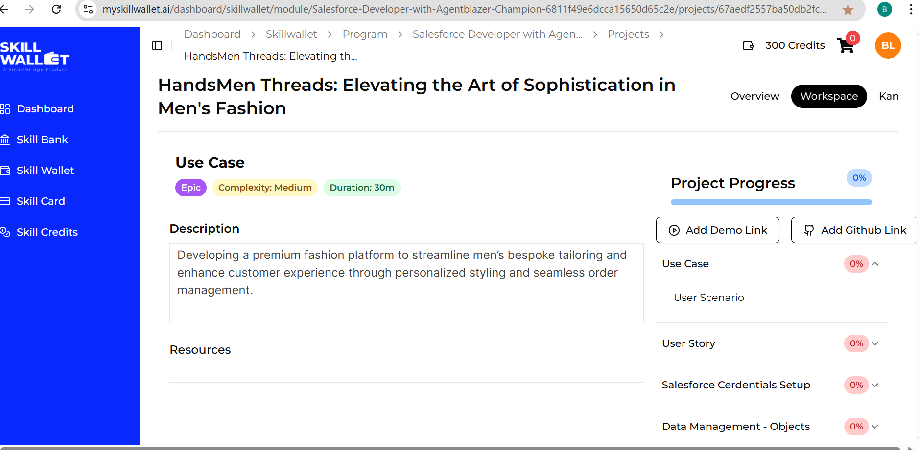

Screenshot:

